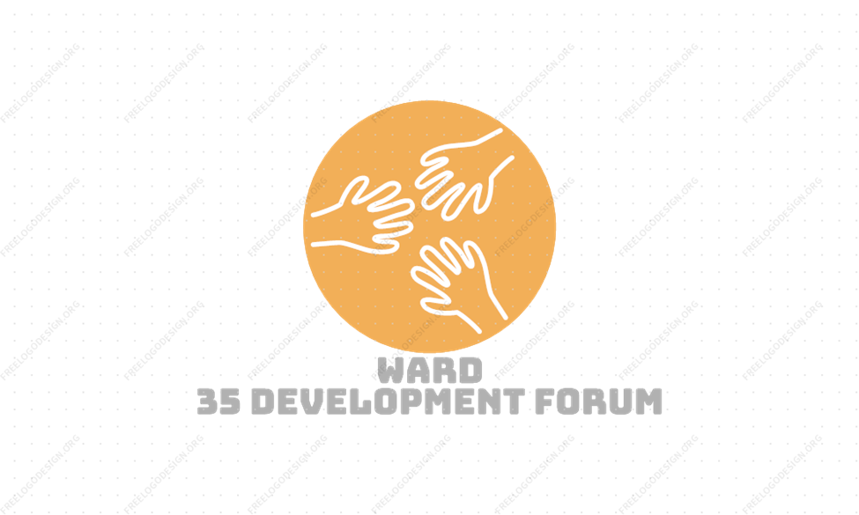

MODEL CONSTITUTION
Table of Contents
1. NAME ............................................................................................................................................ 3
2. BODY CORPORATE ........................................................................................................................ 3
3. VISION and OBJECTIVES ................................................................................................................ 3
4. GOVERNING STRUCTURE AND MECHANISM OF GOVERNANCE ................................................... 4
5. POWERS OF THE ORGANISATION ................................................................................................. 5
6. MEMBERS………………………………………………………………………………………………………………………………… 5
7. MEETINGS ..................................................................................................................................... 6
8. INCOME AND PROPERTY................................................................................................................ 8
9. FINANCES AND REPORTS ............................................................................................................... 9
10. AMENDMENTS TO THE CONSTITUTION ...................................................................................... 9
11. DISSOLUTION/CLOSING DOWN...................................................................................................10

1. NAME
1.1 The organisation hereby constituted will be called Ward 35 Development Forum
1.2 Its shortened name will be WDF 35 (Hereinafter referred to as the organisation).

2. BODY CORPORATE
The organisation shall:
- Exist in its own right, separately from its members.
- Continue to exist even when its membership changes and there are different office bearers.
- Be able to own property and other possessions.
- Be able to sue and be sued in its own name.

3. VISION and OBJECTIVES
The organisation’s vision is to see a community that is prosperous, safe and improving the lives of members within the Ward 35 area.
The organisation’s main objectives are to:
- The primary aim of the Ward 35 Development Forum is to ensure and encourage ongoing socio-economic development of the Ward, it’s residents, businesses, organisations, civic bodies and infrastructure. To this end we have set the following objectives:

b) The organisation’s secondary objectives will be to:
- Community Liaison Function
  - To act as a liaison with all developments and projects occurring within the Ward 35 community to ensure that Ward 35 community members and businesses are able to participate in these projects and that they operate in the best interests of the community as a whole.
  - To ensure local Community Liaison Officers are appointed from Ward 35 in a rotational system that allows all sectors of Ward 35 to participate.
- Training and Development
  - To encourage training and development endeavours for local for profit businesses and craftsman as well as not for profit organisations in order that they may continually improve and be able to engage in development opportunities as they arise.
- Civic Society Development
  - To establish local civic organizational networks and social structures (such as Youth, Sports, Health, Education, Social Development, Gender Equality, Crime and Violence Prevention Forums and Networks)
- General
  - To participate in city-wide, provincial and national projects and partnerships as and when they will be beneficial to the Ward.

4. GOVERNING STRUCTURE AND MECHANISM OF GOVERNANCE
4.1 The Office Bearers will oversee the organisation. The Office Bearers will be made up of at least 10 to a maximum of 18 members. They are the Board of governance of the organisation.
4.2 Term of office: Office bearers will serve for a period of 3 years which has been agreed to by the general membership at an AGM, and which shall not exceed three years. They can, however, stand for re-election for another term in office again and again after that, for so long as their services are needed and they are ready to give their services.
  - Elections
4.3.1 Board members shall be elected at the Annual General Meeting. Members of the Association may nominate people for the Board. Once nominated individuals have indicated their willingness to serve on the Board, members of the Association will vote on the nomination(s). If there are more nominations than the number of Board positions available, the nominee(s) with the most votes will be elected.
4.3.2 Board members shall be members of the Association and meet the criteria below in section 6. It should also be noted that no persons or organisations should be precluded from becoming a member or being elected to the Board of the Ward 35 Development Forum on the basis of race, gender, class or political affiliation.
4.3.3 The Board shall comprise at least 10 but not more than 18 members. The membership of the Board shall comprise: the Chairperson; Vice-Chairperson; Treasurer; Secretary; Vice-Secretary and nominations should seek to ensure that all sectors (e.g. Lower Crossroads, Luzuko, Thabo Mbeki, Island, Marikana 1, Marikana 2, Rholihlahla, Seskhona, Winnie Madikizela, Manguang, etc) of Ward 35, as are present at the time of the AGM and that people are elected who are capable of serving in the various portfolios (Business, Sports, Youth, Social Development, Education, Religious, Safety and Security, etc) as are decided from time to time.
4.4 Vacancies: The Office Bearers must, as soon as reasonably possible, appoint someone to fill any vacancy that reduced the number of Office Bearers.
4.4 Resignation: An Office Bearer may resign from office in writing.
4.5 Disqualification or Removal If an Office Bearer does not attend three meetings in a row, without having applied for and obtaining leave of absence from the Board, then the Board will find a new member to take that person’s place.
5. POWERS OF THE ORGANISATION
5.1 The Board shall carry out the powers on behalf of the organisation and they shall manage the affairs of the organisation in accordance with the resolutions of the members as shall be taken from time to time at General Meetings of the organisation.
5.2 The Board is responsible for making decisions, and acting on such decisions, which it believes it needs to make in order to achieve the objectives of the organisation as stated in point number 2 of this constitution. However, such decisions and their activities may not be against the resolutions of the members or be against the law of the Republic of South Africa.
5.3 The Board shall have the general powers and authority to:-
5.3.1 raise funds or to invite and receive contributions.
5.3.2 buy, hire or exchange for any property that it needs to achieve its objectives.
5.3.3 make by-laws for proper governance and management of the organisation.
5.3.4 form sub-committees as and when it is necessary for proper functioning of the organisation
5.4 If the Board thinks it is necessary, then it can decide to set up one or more sub-committees. It may decide to do this to get some work done quickly. Or it may want a sub-committee to do an inquiry, for example
5.5 The Board may delegate any of its powers or functions to a sub-committee provided that:-
5.5.1 such delegation and conditions are reflected in the minutes for a meeting
5.5.2 at least one Office Bearer serves in the sub-committee.
5.5.3 there are three or more people on a sub-committee.
5.5.4 the sub-committee must regularly report back to the Board on its activities.
5.6 The Board must in advance approve all expenditure incurred by the sub-committee, and may revoke the delegation or amend the conditions of the delegation.

6. MEMBERS
6.1 The membership shall be those persons whose names and signatures appear on the Membership Register of the Association. There shall be no less than 18 members at any time.
6..2 The Board may admit further members from time to time:

6.2.1 Subject to due compliance with any conditions of membership which the Board may stipulate from time to time; and
6.2.2 In accordance with the following criteria:
- That the potential member be resident within the boundaries of Ward 35
- Or that the potential works in an organization which operates within the boundaries of Ward 35.
- Subscribes to the Forum’s objectives and values.
6..3 The Board may suspend or terminate the membership of any member provided that:

6.3.1 At least (14) fourteen days prior written notice is given to all members of the Board of the intention to terminate a membership; and

6.3.2 At least (14) fourteen days prior written notice is given to the member concerned. The notice shall invite the member to make written or verbal representations to the meeting as the member may consider appropriate.

6.4 The decision of the Board to admit an applicant to membership, or to suspend or terminate a membership shall lapse unless confirmed by a resolution of two thirds of the members of the Association present at the next General Meeting.

7. MEETINGS
7.1 Annual General Meetings (AGM)
7.1.1 Stakeholders of the organisation must attend its annual general meetings.
7.1.2 The purpose of an Annual General Meeting (AGM) is to:
- Report back to stakeholders from the Office Bearers on the achievements and work of over the year.
- Make any changes to the constitution.
- Enable members to decide on the policies of the organisation.

7.1.2 The annual general meeting must be held once every year, towards the end of the organisation’s financial year.
7.1.3 The organisation should deal with the following business, amongst others, at its annual general meeting:
- Agree to the items to be discussed on the agenda.
- Write down who is there and who has sent apologies because they cannot attend.
- Read and confirm the previous meeting’s minutes with matters arising.
- Chairperson’s report.
- Treasurer’s report.
- Changes to the constitution that members may want to make.
- Elect new office bearers.
- General.
- Close the meeting.

7.2 Special General Meetings
7.2.1 The Special General Meeting (SGM) or any other special meeting is held outside of the normal or regular meetings.
7.2.2 Special or extraordinary meetings can take the shape of an Annual General Meeting (AGM) or any ordinary meeting of members.
7.2.3 The Board or not less than one-third of the members may call a Special General Meeting of the organisation.
7.2.4 Special meetings may be called when the Board needs the mandate or guidance of the general members of the organisation to take up issues that require urgent attention and cannot wait until the next regular AGM or ordinary meeting.
7.3 Ordinary Meetings
7.3.1 Ordinary members meetings are conducted to complete a standard order of business of the organisation. These are held once a quarter and are attended by the board.
7.3.2 The meetings of the Board will be held at least once a quarter or when a need arises from time to time to conduct the business of the Board.
7.4 Notices of Meetings
7.4.1 The Chairperson of the Board shall convene meetings. The Secretary must let all Board members know the date of the proposed meeting within a reasonable time, but not less than seven (7) days, before it is due to take place.
7.4.2 However, when convening an AGM, or a Special General Meeting, all members of the organisation must be informed of the meeting no less than fourteen (14) days before such a meeting.
7.4.3 Notices for all meetings provided for in this constitution must be given to relevant members in writing, either personally, by post or electronic communication or whichever manner it is convenient, to the address or other similar particulars provided by the members.
7.4.4 The notices for all meetings must indicate the reasons for the meeting and the matters that will be discussed in the meeting.
7.4.5 For confirmation of delivery, all notices sent to members at the latest known contact details shall be deemed to have been duly served on members, unless it can be proven otherwise.
7.4.6 All members present in person at any meeting shall be deemed to have received notice of such meeting.

7.5 Quorums
7.5.7 Quorums for all meetings of the organisation shall be a simple majority (50% + 1) of relevant members who are expected to attend
7.5.8 However, for the purpose of considering changes to this constitution, or the dissolution of the organisation, then a two thirds (⅔) of the members shall be present at a meeting to make a quorum before a decision to change the constitution is taken.
7.5.9 All meetings of the organisation must reach a quorum before they can start.
7.5.10 If, however a quorum is not present within fifteen minutes of the appointed time of the meeting, and a quorum is required for voting purposes, the meeting must be adjourned or postponed to another date, within fourteen days thereafter.
7.5.11 If no quorum is present at the reconvened meeting within fifteen minutes of the appointed time, the members present shall be regarded to make up a quorum for that meeting and the meeting will continue as if a quorum is present.

7.6 Procedures at Meetings
7.6.1 The Board may regulate its meetings and proceedings as it deems fit, subject to the following:
- That the Chairperson shall chair all meetings of the organisation, including that of the Board.
- That, if the Chairperson is not present, the Vice-Chairperson shall chair such meeting. In the event both are absent, the Board members present at the meeting shall elect a chairperson for that meeting.

7.7 Making decisions in meetings
7.7.2 Where possible, the decisions of the organisations shall be taken by consensus. However, when there is no consensus, then members will discuss options for a while and then call for a vote.
7.7.3 All votes shall be counted and the majority votes on an issues shall be regarded as the decision of the meeting
7.7.4 However, if opposing votes are equal on an issue, then the chairperson in that meeting has either a second or a deciding vote.
7.7.5 All members must abide by the majority decision
7.7.7 Decisions concerning changes to this constitution, or of dissolution and closing down of the organisation, shall only be dealt with in terms of clauses 9 and 10 of this constitution.
7.8 Records of meetings
7.8.1 Proper minutes and attendance records must be kept for all meetings of the organisation.
7.8.2 The minutes shall be confirmed as a true record of proceedings by the next meeting of the Board, or of general members as the case may be, and shall thereafter be signed by the chairperson.
7.8.3 Minutes shall thereafter be kept safely and always be on hand for members to consult.

8. INCOME AND PROPERTY
8.1 The organisation will keep a record of everything it owns.
8.2 The organisation may not give any of its money or property to its members or the Board. The only time it can do this is when it pays for work that Office Bearers or a member has done for the organisation. The payment must be a reasonable amount for the work that has been done.
8.3 The Board or a member of the organisation can only get money back from the organisation for expenses that she or he has paid for or on behalf of the organisation, and for which authorisation has been granted.
8.4 The Board or members of the organisation do not have rights over things that belong to the organisation.
9. FINANCES AND REPORTS
9.1 Bank Account: The Board must open a bank account in the name of the organisation with a registered Bank.
9.2 Signing: Cheques and other documents requiring signature on behalf of the organisation shall be signed by at least two persons authorized by the Board. Whenever funds are taken out of the bank account, the chairperson and at least two other members of the organisation must sign the withdrawal or cheque.
9.3 Financial year-end: The financial year end of the Organisation shall be end of December each year.
9.4 Financial Report: The Board must ensure that proper records and books of account which reflect the affairs of the organisation are kept, and within six months of its financial year a report is compiled by an independent registered Accounting Officer stating whether or not the financial statements of the organisation are consistent with its accounting policies and practices of the organisation.
9.5 The Treasurer is responsible for making sure that the money of the organisation is safe and is accounted for.
9.6 The Treasurer must also make regular reports to the Board on the finances of the organisation, which should include all incomes, expenditures and balances that remain according to accounting practices of the organisation.
9.7 If the organisation has funds that can be invested, the funds may only be invested with registered financial institutions. These institutions are listed in Section 1 of the Financial Institutions (Investment of Funds) Act, 1984, or as shall be amended. Or the organisation can get securities that are listed on a licensed stock exchange as set out in the Stock Exchange Control Act, 1985 (as amended). The organisation can go to different banks to seek advice on the best way to look after its funds.
10. AMENDMENTS TO THE CONSTITUTION
10.1 The constitution can only be changed by a resolution. The resolution has to be agreed upon and passed by not less than two thirds (⅔) (or at least 67%) of the members who are at the annual general meeting or special general meeting. Members must vote at this meeting to change the constitution.
10.2 For the purpose of considering changes to this constitution, a two thirds (⅔) of the members shall be present at a meeting to make a quorum before a decision to change the constitution is taken. Any annual general meeting may vote upon such a motion, if the details of the changes are set out in the notice referred to in clause 6 of this constitution
10.3 As provided for in clause 6, written notices must go out not less than fourteen (14) days before the meeting at which the changes to the constitution are going to be proposed. The notice must indicate the proposed changes to the constitution that will be discussed at the meeting.
10.4 No amendments may be made which would cause the organisation to close down or stop to function or die away.
11. DISSOLUTION/CLOSING DOWN
11.1 The organisation may dissolve or close down if at least two thirds (⅔) of the members present and voting at a meeting convened for the purpose of considering such matter, are in favour of closing down.
11.2 When the organisation closes down it has to pay off all its debts. After doing this, if there is property or money left over it should not be paid or given to members of the organisation. It should be given in some way to another non-profit organisation that has similar objectives. The organisation’s general meeting can decide what organisation this should be.
This constitution was approved and accepted by members of Ward 35 Development Forum (WDF35)
At a special (general) meeting held on

-------------------
Day/Month/Year

----------------- -----------------------------
Chairperson Secretary

